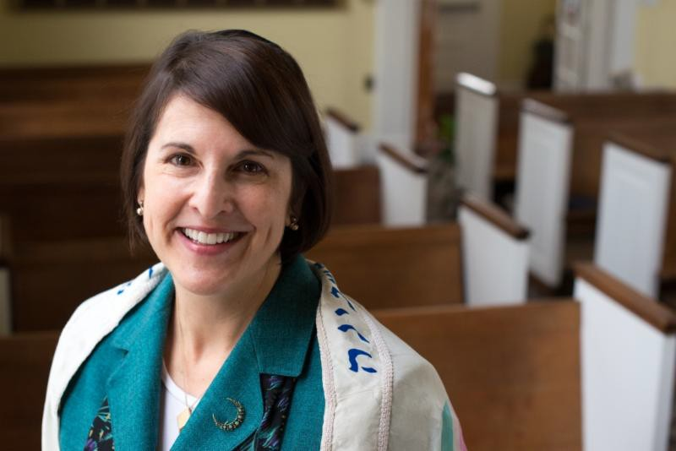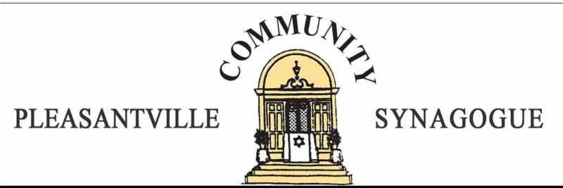

VOLUME XXIII, NUMBER 5 WWW.SHALOMPCS.COM JANUARY 2018

The Rabbi's Column:

What Happens After B'nei Mitzvah?

by Rabbi Dr. Julie Hilton Danan

Many of you may know that every month I lead a parent-child education program for all the B'nei Mitzvah class families. We do things like go on hikes, volunteer or learn to put on tefillin. B'nei Mitzvah at PCS are very meaningful and moving, thanks to our wonderful teachers, dedicated volunteers, dynamic Hebrew School director Galit Sperling, and fantastic Tutor/B'nei Mitzvah Chair Ed Sperling. I'm glad that B'nei Mitzvah at PCS are such a meaningful and transformative process for our kids, and their parents along with them.
Now it's time to have equally meaningful and involving programs for teens after seventh grade. As we always say to our students, B'nei Mitzvah is not an end in itself. Jewish education does not end in junior high. B'nei Mitzvah should be about "becoming" - becoming an active young adult member of a community and a people. When I was writing my book for Jewish parents a few years ago, I learned that research indicates that "continuation of Jewish studies through high school is considered by some researchers to be one of the critical predictors of adult Jewish identification and observance."
At a recent B'nei Mitzvah parent-child program that Galit and I co-led on "Putting God on the Guest List" (based on a book by that name that all the parents receive), the students were asked to share their questions about the process. One of them wrote, "What happens after Bar/Bat Mitzvah?" I'm afraid that we still haven't answered that question satisfactorily, but I hope that in 2018 we will be able to do so. I'm proud that we have realized a lot of goals since I came to PCS over two years ago. But one of my most cherished goals has yet to come to fruition: to develop a teen program, including an education program (along the lines of the Reform movement's

confirmation classes) and a youth group for our teens.

Last year we were off to a good start as we hired Julia McCarthy to be our part-time youth director, and she led monthly programs for our teens. We joined a cohort of other synagogues to learn and do teen programs. About 10 teens joined Julia and me for dinner last spring (funded by a mini-grant from the Westchester Jewish Teen Learning Initiative), and we planned an even fuller program for this year that would focus on monthly programs on Judaism and the environment. When Julia left over the summer to start a full-time position, we were in the middle of major budget cuts and other changes, and were simply not able to get this new program going this fall. I regret that and apologize to our teens and parents for the setbacks on our plans.
Fortunately, we are getting back on track. After our recent PCS service afternoon at the
JCCA, five PCS teens - Isaac Gordin, Sydney Schulz, Miranda Miller, and Jordan and Molly Galin - met with me and board member Laurie Hirsch Schulz at Jean-Jacques to "reboot" our program for the spring. We decided to maintain our focus on Judaism and the environment/ nature for this spring, while also engaging in service and social programs. Later some of us connected with Aydin Mayers, our PCS member and song-leader who is a regional and national leader in the BBYO (B'nai Brith Youth Organization) movement. He encouraged us to restart a BBYO Youth Group as one of our teen offerings. PCS board member Robin Berman, a high school teacher, has kindly volunteered to be the adult advisor for that teen-led group.

Our first teen program for 2018 will be on Monday, January 15, participating in a county-wide MLK Teen Service Day with J-Teen at Westchester Reform Temple in Scarsdale (see flyer below). Students are encouraged to bring friends (Jewish or not).
Carpools need to be arranged from PCS. Please sign up now! PCS participants will meet at PCS on that Monday at 9:30 am to carpool together, returning to PCS at 1:30 that afternoon. Registration and parent permission slips are required - all available on this site: https://www.eventbrite.com/e/mlk-day-disaster-relief-with-the-afya-foundation-tickets- 39730658469. If you have questions, please contact the PCS office.
Our group discussed programs for the rest of this spring. For February, we will schedule a teen kickoff pizza dinner at PCS, date soon TBA. Later in the spring, we aspire to participate in the newly formed Pleasantville Interfaith Youth Group (organized through St. John's Episcopal Church) to experience a nature program with the Rewilding Institute, (https://www.rewildingschool.com) and to have one or more educational ecology programs led by a student rabbi from the Academy for Jewish Religion. We plan to charge a small amount for some programs to cover costs. The teens were also willing to lead a Shabbat service later in the spring. Finally, Laurie Hirsch Schulz and her daughter Sydney have been looking into a teen Shabbat retreat at Surprise Lake Camp. This is something we have been dreaming of for a long time.
Our goal for the spring is to establish an active youth group (hopefully BBYO) being led by the kids with educational components, AND in the fall to launch a high-quality, fun educational program, taught by me with the help of AJR student rabbis. I envision a set of rotating annual themes (Environment, American Judaism, Israel), with very participatory programs and exciting field trips.
If you have a teen son or daughter, please, please encourage them to come to the January 15 MLK service day and our other upcoming teen programs. We would also love to have them join our teen steering committee. The teens are young adults, and we want them to help plan their own events and goals.

Friends, a quality teen program is not an extra, a bonus or an afterthought. Teen education and involvement can be vitally important to our students, to our PCS

community's future and indeed to the future of the Jewish people. It is also one of my personal priorities and values. Although we have hit some speed bumps along the road, this is one priority that I'm not willing to forsake, and I hope that it will be as important to all of you as it is to me. Please support our program. I welcome your involvement, and if you have any questions or ideas, don't hesitate to communicate!
Best wishes for a great 2018!

HEBREW SCHOOL HAPPENINGS
by Galit Sperling, Principal

This December, the students of the PCS Hebrew School were excited to prepare for, and celebrate, the Festival of Lights - Hanukkah! Students of every age learned about Hanukkah in a myriad of ways: through history, modern-
day application of Jewish values, arts and crafts, and more!

Below are photos from the traditional visit of Hebrew School students to the Atria in Briarcliff Manor, where we sang songs with senior residents and their families, and students handed out cards and gelt. Following this wonderful mitzvah, we came back to PCS for the congregation-wide Hanukkah party, where we decorated and spun dreidels, enjoyed a delicious latke competition, and lit a record-setting number of menorahs for the sixth night of Hanukkah!

The story of the Macabees' victory and the rededication of the Temple became quite relevant to our small community of Pleasantville on December 22, as we had our own "re-dedication" in the community square on Manville Road. It was wonderful to see so many Hebrew School families and community members coming together to light up the night with hope, singing together around our town's new dreidel.

This winter brings several exciting class events to look forward to for our Hebrew School students and families - see below!

Upcoming Hebrew School Dates:

Thursday, January 4: Classes Resume
Sunday, January 14 (MLK Jr. Weekend): No Classes
Friday evening, January 19: Kitah Vav (sixth grade) Class Shabbat Ritual Dinner
Saturday evening, January 27: Kitah Hey (fifth grade) Havdalah Service Friday evening, February 2: B'nei Mitzvah Class (seventh grade) Shabbaton Sunday, February 4 (Teacher Kallah): No Classes

Singing at the Atria
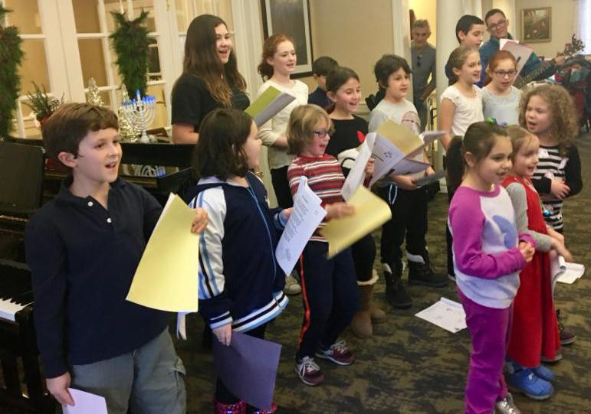

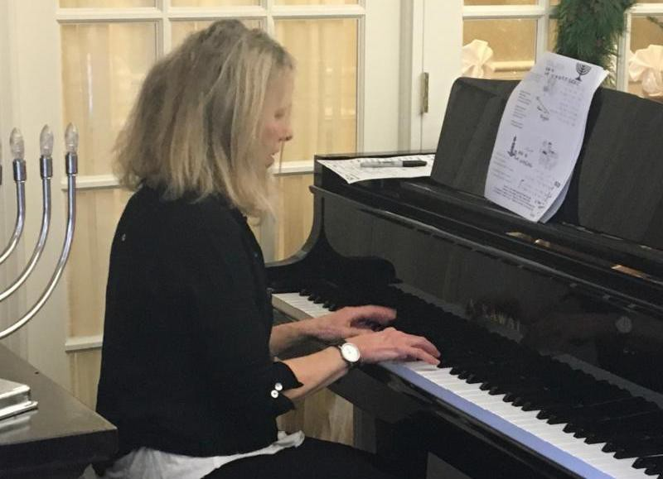
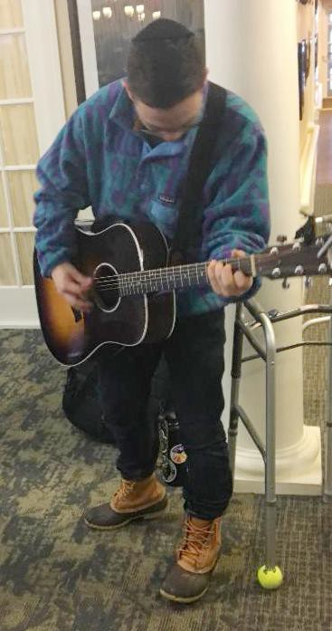
Musicians Karen and Aydin accompanying our students at the Atria

Hebrew School students at the PCS Hanukkah party

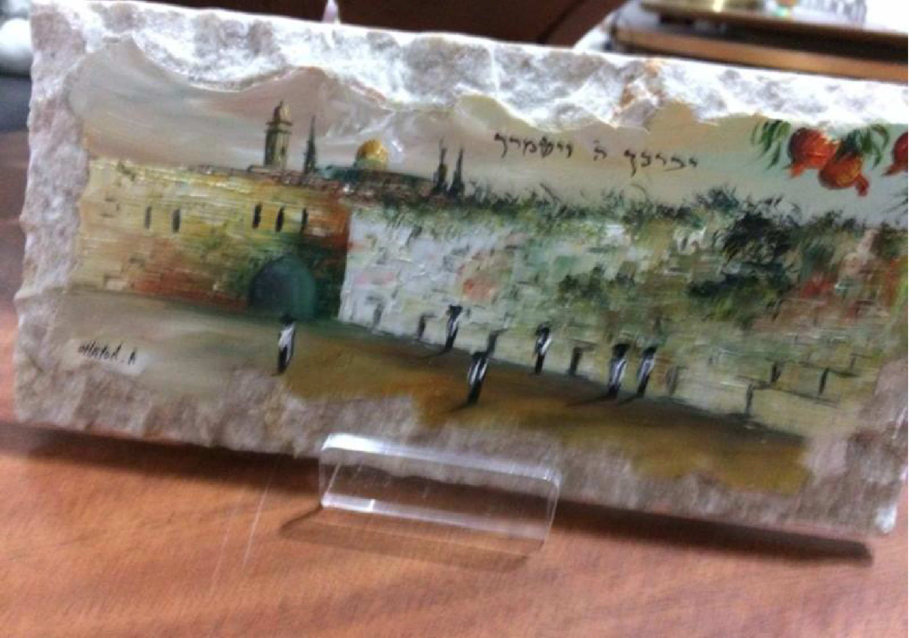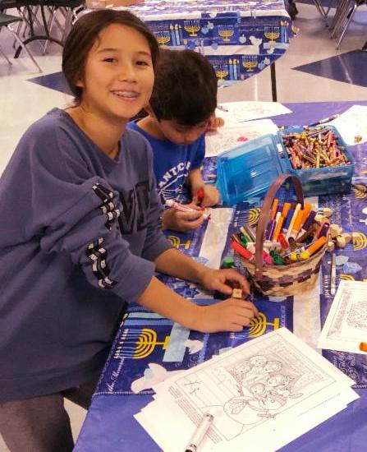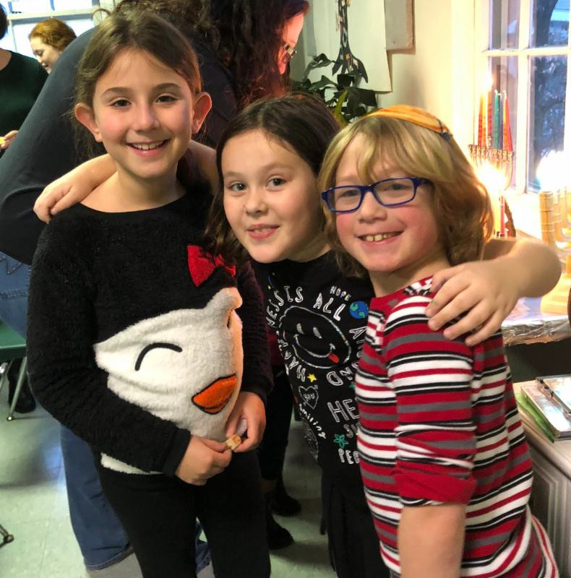

Post cards from Eret z Yi srael*

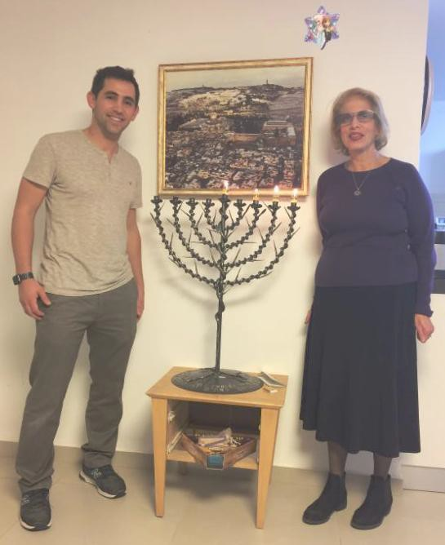
Shalom!
Here I am with my friend
Yedidya, celebrating Hanukkah at his
home. We are standing alongside a hanukkiah made from a rocket that landed in Israel in July 2014.

This is my Hanukkah gift from my Bedouin brother, Hashem. It is made of Jerusalem stone and has a drawing of the Kotel on it.

Hashem is going to invite me to a Bedouin wedding. That should be an interesting
experience. I do have a Bedouin outfit that I have worn for Purim. I guess it would be nice to wear it for another occasion.

L'hitraot, Rachel
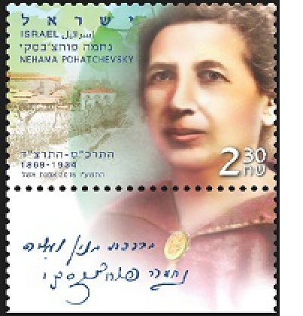
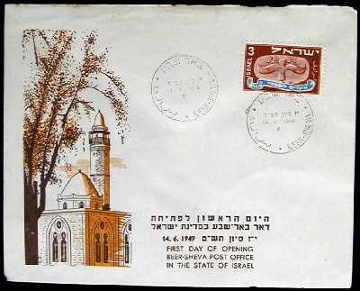
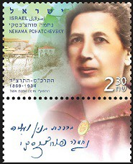

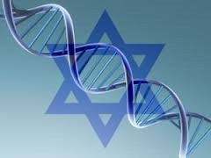*Our corresp ondent is Rhea ( Ra chel) Wolftha l, long- time PCS congrega nt, who ma de a liya h to I sra el in August 2017.

Please join us for this free lecture and discussion, sponsored by the PCS Adult Education Committee:

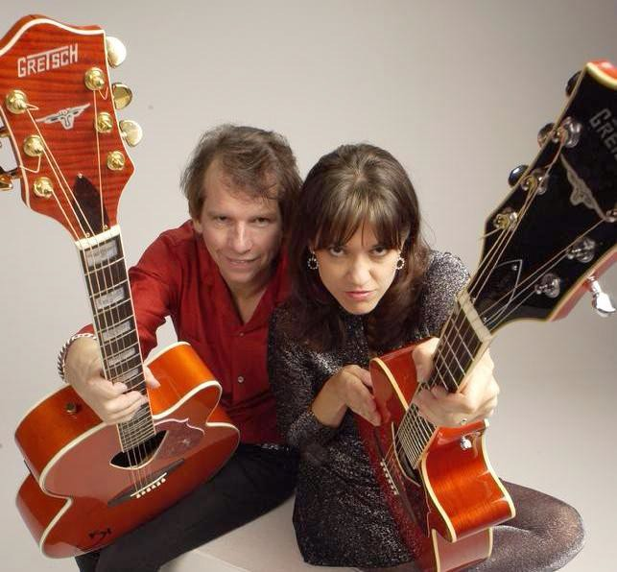
Photo: Hub Wilson
THE KENNEDYS IN CONCERT AT PCS!
"JEWISH WOMEN AND BREAST CANCER"
Tuesday, Jan. 9, 7:30 pm
Pres ented by Dr. Rand Stack, this could be the one program you don't want to mis s . All are welcome to this free event, which is not for women only.
For more info, e-mail Adult Education committee chair,
Barbara Doctor, or call the PCS office at 914-769-2672.
Click here for Dr. Stack's bio.

Pleasantville Community Synagogue www.ShalomPCS.com
(914) 769- 2672, info@shalomPCS.com 219 Bedford Road, Pleasantville, NY

Saturday, Jan. 13, 8 pm
In the spirit of Martin Luther King, Jr., Day, the popular folk-rock band The Kennedys will perform at PCS to help support Ezra Uganda.
The Jews of Eastern Uganda, about 2,000 in number, are devout in Jewish practice. They subsist almost entirely on small farming and raising goats for sale. The funds collected from The Kennedys' concert at PCS beyond our expenses will be donated directly to Ezra Uganda
for the purchase of a plow and oxen.

Visit www.ezrauganda.org.

The cost of admission is $20 (but of course any donations above that are more than welcomed and greatly appreciated!)

For more information or to RSVP and pay, please click here or copy and paste: https://the-kennedys-in- concert-at-pcs.cheddarup.com
This will be a wonderful night for a great cause.
Please join us!
If you'd like to help, please contact
Tikkun Olam/Social Action Committee chair, Leslie Mack, at lesrn3259@aol.com or call the PCS office at 914-769-2672.
~~~
Pleasantville Community Synagogue
219 Bedford Road, Pleasantville, NY
(914) 769-2672, info@shalomPCS.com, www.ShalomPCS.com

IMPORTANT NOTICE!
PCS participants will carpool to the following event together, meeting at PCS at 9:30 am and returning to PCS at 1:30 pm. Please RSVP, or if you can be a driver, please contact Laurie Hirsch Schulz at lhirschschulz@gmail.com or call the PCS office at 914-769-2672.
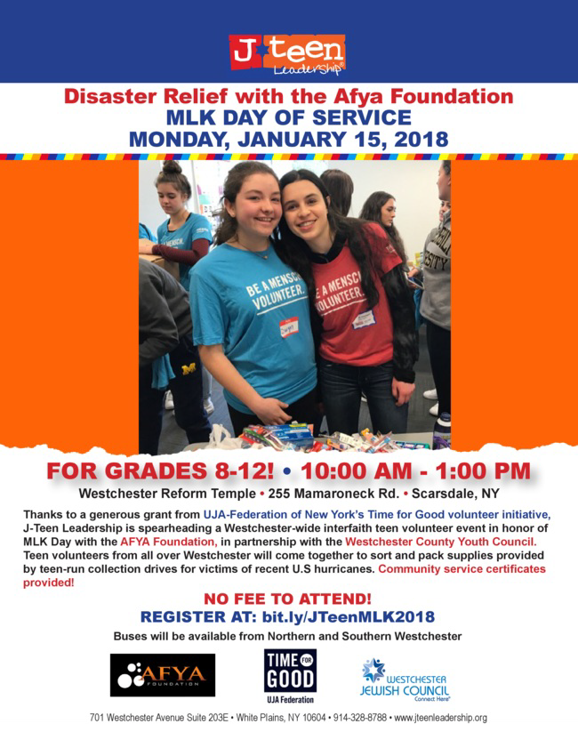

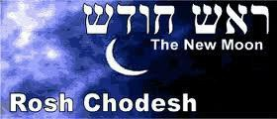Come to PCS to celebrate Tu B'Sh'vat and

ROSH CHODESH!*
Wednesday, January 17,
7:30 pm
at Pleasantville Community Synagogue

We'll have a mini-seder in honor of Tu B'Sh'vat, the New Year of Trees, when we celebrate
the environment and appreciate the fruits of the Land of Israel.
Lots of fun with lots of good food, wine, and company!

To RSVP or for more information
call Marcy Gray at PCS at 914-769-2672 or
e-mail Robin Berman at awake.robin@gmail.com.
* Why do we celebrate the new moon every month? The Jewish nation is often compared to the moon.
Throughout history our light has waxed and waned but even in the darkest times it has never been extinguished. This is one reason why, when the head of the new moon - the Rosh Chodesh - appears for the first time in the night sky, we celebrate. Come join us!
~~~
Pleasantville Community Synagogue ~ 219 Bedford Road, Pleasantville, NY (914) 769-2672, info@shalomPCS.com ~ www.ShalomPCS.com

Celebrate Tu B'Sh'vat with the little ones!*
Sunday, January 28,
9:15 am-10:45 am

~ Arts and crafts ~ Snacks
~ Stories and books from PJ Library

*The event will take place at a member family's home around the corner from PCS in Pleasantville. For more information and to RSVP, please contact Marcy Gray in the PCS office, mgray@shalompcs.com, 914-769-2672.

~~~
Pleasantville Community Synagogue
219 Bedford Road, Pleasantville, NY
www.shalompcs.com ~ 914-769-2672 ~
info@shalompcs.com

Pleasantville Community Synagogue
Progressive Dinner Invitation!
Saturday night, February 3, 2018
Enjoy an exciting evening progressing from one home to the next. Meet new people and have fun and great food in a relaxed, warm atmosphere!
Meet for hors d'oeuvres at the home of Kathy Schuler & Jon Blackman. Draw one of our host names and proceed to their home for the entrée. Gather again with everyone for dessert at the home of Claire & Oren Cohen.

Sign up as a host or come as a guest and bring an appetizer or dessert...
Please fill out the form below and send in with a check for $20 per guest (not required of hosts). Make checks payable to PCS and return to PCS, P.O. Box 148, Pleasantville, NY 10570.
Att'n: Marlo Klein.

Or click on or copy and paste the link below to sign up online:
https://pcs-annual-progressive-dinner.cheddarup.com

Or feel free to email Marlo Klein at pcsprogressivedinner18@gmail.com

----------------------------------------------------------------------------------------------------------------

Name(s): _____________________________________________________________________ Cell phone and e-mail:____________________________________________________ Would you like to host a dinner at your home? Yes____ No_____
If yes, how many guests can you accommodate?______
Are you able to host a Kosher or Vegetarian dinner? Which?

If you cannot host a dinner, please bring: Appetizer________ or Dessert____________

Let us know if you have a special dinner request: Kosher ___ Vegetarian____

Any other special considerations (e.g., allergies)?____________________________________

JACOB BURNS FILM CENTER

Coming Soon...

Tickets for the 2018 Westchester Jewish Film Festival will go on sale in mid-February for the annual festival that will run from March 13-29 at the Jacob Burns Film Center in Pleasantville. This year's festival will feature 38 films, a robust mix of documentaries and narratives. Many of
the films will be followed by speakers, audience Q&As, and receptions. For complete information, please visit burnsfilmcenter.org in February. For additional information and group sales, please contact Abby Popper at apopper@burnsfilmcenter.org or 914.773.7663, ext. 424.

CONTRIBUTIONS
We appreciate the thoughtfulness of those who support
the Pleasantville Community Synagogue by remembering and honoring their friends and loved ones through their generous contributions.
For information on making donations to PCS, including online donations, please click here.

Fair Share /General Fund Jan and Bernie Gordon Teddi and Murray Stahl Greg Cohen
Bruce Gutenplan Peter Schaffer Evan Kingsley Eric Klein
Bernie Gordon Richard Solomon Oren Cohen
Leslie Mack and Robin Freedman Susan and Alan Friedman
Erica Murkofsky and Michael Rhodes Barbara Altman Bruno and Joe Bruno
The Ehrlich and Ponet families, in thanks to PCS for hosting the Brit Milah of Levi Joshua Ehrlich, son of Shula and Nathan

Hebrew School Fund
Hedi and Ed Sperling, in honor of the yahrzeits of Hedi's beloved parents, Elizabeth (Blima) and Dov Weiss, and Ed's beloved mother, Margaret Sperling.

JANUARY YAHRZEITS

Fanny Goldman, grandmother of Dorian Goldman January 1
Alexander Gordon, father of Bernard Gordon January 4
Marvin Levine, father of Richard Levine January 5
Edith Mayers, grandmother of Michael Mayers January 8
Odon Vesei, father of Ann Vesei January 8 Regina Fisher, grandmother of Dorian Goldman January 14 Kenneth Wolf, father of Michael Wolf January 21
Lillian Levine, wife of Richard Levine January 21
Estelle Herman, mother of Diana Benattar January 23
Joel Serebin, father of Ben Serebin January 24
Aaron Netburn, father of Malcolm Netburn January 24
Celia Lubelsky, mother of Janice Sandbank January 25
Leslie Ogrin, father of Mara Cohen January 28
Marion Gaines, mother of Jonathan Church January 28

To all PCS members:
If you or another member suffer personal tragedy or loss or are otherwise in need of help, please immediately contact Rabbi Julie at (914) 769-2672 or Rabbi@ShalomPCS.com, or to our Caring (Chesed) Committee Chair, Susan Friedman at (917) 846-3038, or SFriedman@ShalomPCS.com.

The PCS Yahrzeit Memorial Board is a beautiful and symbolic place to honor your loved ones while helping to support your synagogue. The anniversary of their passing will be commemorated with a light by their name plate. You will find the appropriate form for purchasing a memorial name plate by clicking here.

Pleasantville Community Synagogue Mission Statement
P l e a s a n tv i l l e C o m m u n i ty S y n a g o g u e i s a w e l c o m i n g J e w i s h c o m m u n i ty c o n n e c ti n g p e o p l e o f d i v e rs e tra d i ti o n s a n d
ba c k g ro u n d s w h o w a n t to s h a re a j o y o u s s p i ri tu a l a n d
c u l tura l h o m e .

PCS officers and trustees:
Officers
President: Leyla Nakisbendi Secretary: TBD
Treasurer: Oren Cohen
Vice President: Roberta Korus Vice President: Richard Solomon

Board of Trustees

David Benattar dbenattar@ShalomPCS.com
Robert Marshak rmarshak@ShalomPCS.com

Robin Berman rberman@ShalomPCS.com
Leyla Nakisbendi lnakisbendi@ShalomPCS.com

Gregory Cohen gcohen@ShalomPCS.com
Karen Neuburger kneuburger@ShalomPCS.com

Oren Cohen ocohen@ShalomPCS.com
Lisa Nicotra lnicotra@ShalomPCS.com

Jonathan Goodman jgoodman@ShalomPCS.com
Laurie Hirsch Schulz lhirschschulz@ShalomPCS.com

Amy Gutenplan agutenplan@ShalomPCS.com
Ben Serebin bserebin@ShalomPCS.com

Roberta Korus rkorus@ShalomPCS.com
Richard Solomon info@ShalomPCS.com

Sheila Major info@ShalomPCS.com
Rabbi Julie Danan rabbi@ShalomPCS.com

To contact PCS:
Phone: (914) 769-2672; Fax: (914) 769-1795; Website: www.ShalomPCS.com

Marcy Gray, Synagogue Administrator: (914) 769-2672; mgray@ShalomPCS.com
Galit Sperling, Religious School: (914) 773-0043; principal@ShalomPCS.com Barbara Doctor, Member Accounts: (914) 747-3017; Accounts@ShalomPCS.com

Pleasantville Community Synagogue Newsletter January 2018 14 Tevet - 15 Sh'vat 5778

